Chapter 9, Problem 76.

For the following pairs of signals, determine if v₁ leads or lags v₂ and by how much.
(a) 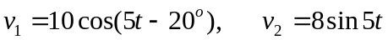
(b) 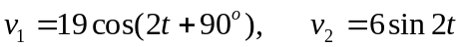
(c ) 